**Brooklyn torah gazette**

**For parshas behar-bechukosai 5780**

Volume 4, Issue 32 (Whole Number 184) 22 Iyar 5780/ 6, May 6 2020

**Printed L’illuy nishmas Nechama bas R’ Noach, a”h**

**Rav Avigdor Miller On**

**The Reason for Sickness**



**QUESTION**: What is the reason for the illness called cancer?

**ANSWER**: What’s the reason for any illness? And so we’ll turn to Rashi. Rashi asks: What’s the reason for all illness? And he says, להכניע את הלב – it’s to make a person’s mind humbled. What does that mean? להכניע את הלב – The purpose of illness is to make a man humbled so that he should cry out to Hashem. The purpose is to cry out to Hashem.

Now pay attention, it says, ענו להשם בתודה – *Cry out to Hashem in thanksgiving.* You have a choice. You have to cry out to Hashem one way or another; so ענו להשם – *Cry out to Hashem,* בתודה – *in thanksgiving*.

An *ani* is a person who cries out from affliction. So you have a choice. You can cry out in thanksgiving, in happiness – when you’re well, when you’re young and everything is alright. And then there’s *chalilah* another way – when he has cancer, *chalilah*.

So cry out to Hashem now while you have the happiness option. Maybe you’ll never need anything else. Maybe you’ll be healthy up until your last minute!

But whatever it is, the purpose of everything in the world is to make you aware of Hashem. And that’s called *hachna’ah*. When people forget about Hashem, so He reminds them. Like when you went out of Mitzrayim, it states ויבא עמלק. So *Chazal* ask, why did Amalek come just then? Is that a time for Amalek to come?

The answer is, they’re walking out of Mitzrayim and they saw a *mapalah* of Pharaoh’s army, and so they’re all thinking, “I’m so happy.” They were loaded down with money, *kesef v’zahav,* all the wealth of Mitzrayim. So for a while they began to forget – that’s how people are when things are going very well.

They start enjoying their things and forget about who gave it to them. They forget about Hashem for a moment — they didn’t entirely forget, but they were *mesiach da’as* for a little bit. ויבא עמלק – Oh! Now they cried out to Hashem again for help. And Hashem said, “It’s good you’re reminding yourself about Me.”

“Amalek is only to remind you about Me,” says Hashem. All the troubles of this world have only one purpose – to remind you of Hashem. But if you wish to be reminded of Hashem because of the good things, then ענו להשם בתודה. Think, “What does *ani* mean after all?” It’s a person who cries out from poverty. But instead of being an *ani,* someonewhocries out in poverty, so choose the other way: ענו להשם בתודה - *Cry out to Hashem in thanksgiving.*

Thank him for what? “I’m not a multimillionaire,” you say. Oh yes you are. If you’re healthy, you’re wealthy. You have a good heart? You’re not running to specialists every Monday and Thursday? Everything is alright more or less? Then, *boruch Hashem,* you’re a millionaire. You’re a multimillionaire! And therefore you should sing to Hashem in thanksgiving. ענו – Cry out!

And that’s what the *matzos* says – *lechem oni.* So the *gemara* says, לחם שעונים עליו דברים הרבה – it’s a *lechem* on which you speak. *Matzos* is for the purpose of talking.

So in Mitzrayim when they ate *matzos* and they suffered, they cried out to Hashem for His help – that was one way of calling out. And then when they went

*Reprinted from the March 15, 2020 email of Toras Avigdor adapted from Tape E5*

**The Connection Between the Sixth Year in the Shemitah Cycle and the Messianic Era**

**From the Talks of the Lubavitcher Rebbe**

**Rabbi Menachem Mendel Schneerson, Zt”l**

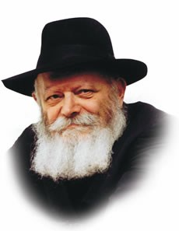

This week's portion, Behar, deals with shemita -- the commandment to allow the land of Israel to lie fallow every seventh year.

It also discusses the laws of the yovel -- jubilee--year -- when all inheritances return to their rightful owners. If you keep these mitzvot properly, G-d promises, "The land shall yield its fruit, and you shall eat your fill, and dwell in safety in it."

Interestingly, it is only after a detailed list of these laws that the Torah mentions a concern that might arise.

"And if you should say, 'What will we eat in the seventh year? Behold, we are not permitted to sow, and we cannot gather in our harvest!'" G-d promises that the sixth year's harvest will be so plentiful that it will be sufficient for three years -- the sixth, seventh, and even eighth year of the cycle.

Why isn't this question included in its logical place, with the rest of the laws of shemita?

Furthermore, the verse "What will we eat?" appears immediately after G-d has already promised that the land will yield its fruit. If so, why is the question even asked?

We must therefore conclude that the question "What will we eat?" contains a deeper significance than merely inquiring about the agricultural yield of Israel.

The question is asked by one who wishes to uncover the inner, spiritual meaning of the mitzva; it therefore appears separately, after the details of the commandment have been delineated.

In truth, the question is how G-d's blessing will be manifested, not if His promise will be fulfilled.

Will G-d cause manna to fall like in the desert, or will He perform a different miracle to sustain the Jewish people?

For in essence, the blessing of the shemita year not only transcends natural law, but utterly contradicts it! According to the laws of nature, every successive year the earth is sown serves to deplete it of its nutrients and goodness; during the sixth year of the cycle, the land would naturally be at its lowest ebb.

This, then, is precisely G-d's special blessing: Despite the fact that according to nature the earth is at its weakest point, the land of Israel will nonetheless yield bountifully.

In the spiritual sense, the six years of working the land are symbolic of the six millennia before Moshiach; the seventh year is symbolic of the Messianic era.

As we are now at the end of the sixth millennium, just prior to Moshiach's arrival, we ask the same question as that of the shemita year: How is it possible that our own spiritually- inferior generation will be able to bring the Redemption?

Once again, the answer lies in G-d's promise to the Jewish people: When we serve Him in a manner that totally transcends logic and understanding, He will surely send us the bounty of Redemption, speedily in our day.

*Reprinted from the archives of L’Chaim Weekly, a publication of the Lubavitych Youth Organization. Adapted from Likutei Sichot of the Rebbe Vol. 27*

**The Way to Look**

**At a Fellow Jew**

**By Rabbi Eli J. Mansour**

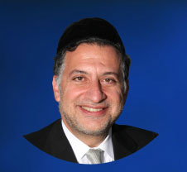

The Torah in Parashat Behar speaks of the obligation to support a fellow Jew in financial straits, adding, "Ve’heh Ahicha Imach" – "and your brother shall live with you" (25:36). We are to help our fellow in distress so he can sustain himself and continue living securely and happily.

The Gemara in Masechet Baba Mesia (62a) brings a famous debate among the Sages relevant to this verse. The case under discussion is two men traveling together in a searing desert, and they run out of water. One traveler has no water left at all, and the other has enough water for only one of them to live. If he shares some of his water with his travel mate, they will both die.

The Gemara cites Ben Petura as teaching, "It is preferable that they both drink and die, rather than one seeing his fellow’s death." In his view, the person with water does not have more rights to his water than his fellow traveler, and so he cannot keep the water for himself.

The Gemara then says that Ben Petura taught this approach "until Rabbi Akiba came and taught, ‘and your brother shall live with you’ – your life precedes that of your fellow." Rabbi Akiba inferred from the expression, "your brother shall live with you" that a person is entitled to sustain his own life before saving his fellow’s life.

Intuitively, we would have assumed without any hesitation that Rabbi Akiba’s position is correct. After all, why should both travelers die, if one life can be saved? And why should the traveler with the water not be entitled to save his life by drinking his own water? Why would he be required to share it?

However, Rav Yerucham Levovitz of Mir (1873-1936) noted that in truth, Ben Petura is fundamentally correct. After all, the Gemara said that Ben Petura taught his perspective until Rabbi Akiva came along and established that this is not the Halacha. This implies that Ben Petura’s view represents the intuitive perspective, and we needed Rabbi Akiba to teach us otherwise.

Rav Yerucham explained that Ben Petura’s view reflects the way we are to look at our fellow Jews – as no less deserving of anything than we are. We are not to feel entitled to any more privileges than anybody else. We are all one and the same.

Even the water in our knapsack must be shared with our fellow Jew, because we are all equal before G-d. We must care for others no less than we care for ourselves. Practically, we are to save ourselves before saving others. But in principle, we must never see ourselves as more deserving of anything than our fellow Jew is.

The story is told of a certain Hesed organization that was interviewing candidates for the position of director general of the organization, and it posed to them the following question:

Imagine you are driving on a frigid, snowy day, and you pass by a bus stop and see three men waiting for the bus. One is an elderly man, shivering from the fierce cold. The other is a doctor on his way to the hospital where patients are waiting for him. And the third is your best friend. The car you drive has only one passenger seat. To whom do you offer a ride?

One candidate said right away that the driver should offer a ride to the doctor, who needs to get to the hospital as quickly as possible in order to treat patients and thereby save lives.

A second candidate said that without doubt, the elderly man, who could get seriously ill waiting out in the cold, should be given the ride. A third candidate disagreed with both, arguing that with friendship comes commitment, and so a person’s best friend takes precedence over everybody else.

But the right answer was given by the fourth candidate. He said that the driver should get out of the car, give the keys to the doctor who should then drive himself and the elderly man, while the driver waits for the bus together with his best friend…

There is no reason to think that we are more entitled to a comfortable ride than those who do not have a car. We are all equally humble creatures sharing G-d’s earth.

Yes, Halacha follows Rabbi Akiba’s opinion, that we are to care for ourselves first. However, Ben Petura’s view must shape our overall outlook on our fellow Jews. If they need our help, we must share what we have with them, and never for a moment believe that we deserve more than they do.

*Reprinted from this week’s website of the Edm0nd J. Safra Synagogue in* Brooklyn.

**Long Lost Relatives**

**By Rabbi Berel Wein**



Because of the increased use of Zoom over the past months, people have been listening to my lectures who otherwise would have been deprived of that great benefit since they do not live in the Rechavia section of Jerusalem. Because of this, as well, I have discovered relatives that I never knew existed and with whom I have had no connection.

The discovery of long-lost relatives always comes as a shock, sometimes in a beneficial way, and sometimes even wondrous. As I have now discovered, I have relatives who live in Edinburgh, Scotland and who have been in the United Kingdom for over a century, families that I never knew existed. I have also discovered that I have relatives here in the United States that somehow disappeared from our family tree and that I never knew as well.

My daughter, who is interested in family genealogy, is creating a family tree for us, which is quite extensive. And now with all this new information, it turns out that we are a far larger family than I ever imagined. This is a wondrous discovery. And seeing what happened in our family, as to where everyone is and how they relate to the origins of our family, is very instructive, not only about my family, but about human nature and about the story of the Jewish people generally, over the past two centuries.

There was once a theory called six degrees of separation. This meant that all human beings were related one to another by no more than six degrees of separation, and if we were to go to the seventh degree, we'd find, so to speak, common ancestors and common family. I think that this is certainly true in the Ashkenazic Jewish world. We have a tradition that, for instance, the 16th century Rabbi from Padua, Italy - Rabbi Moshe Katzenellenbogen - is the ancestor of nearly 80% of Ashkenazic Jewry, who are somehow related to him in one way or another.

This is a fascinating idea, but it helps explain, at least to me, why there is such a strong bond of family that exists within the Jewish people and why its role in our lives is often primary. Jews to a great extent are fixated on family. We are a family religion and a family- built society. There is a great idea in Judaism regarding genealogy, that by knowing who we come from, it sets a course for us and enables us to see where we should be going. It challenges us, it raises us. All Jews see themselves as being aristocrats, as being descended from princes and kings, from priests and scholars, from Holy people and from people who have benefited, all of humankind over the long millennia of our story.

There is an attachment that we all have to members of our family. And the joy of discovering new people that belong to our family is really one of the great benefits that this current period of personal isolation has brought to me. Not only am I alone, but now I am alone with many people that I didn't even know I was alone with. And that is heartening in the extreme.

One of the new long-lost relatives told me that he is considering trying to make a family reunion in Jerusalem, when all of this is over. I made a quick calculation that if everybody from our family would come, now that I know of my extended part of our family, it would be a reunion of three to four thousand people. Now that is a real reunion.

I am reminded that the late Max Weil , who was a friend of mine and a member of our congregation, had organized such a reunion for his family and had thousands of people come to Israel to join in this reunion. He always remarked to me about the diversity in the people who came. They were all related, as they all came from the same place and yet they were all so different. That is a remarkable thing.

I would like to find more long-lost relatives and be able, somehow, to have at least a nodding acquaintance. My immediate family was small and suddenly because of the blessings of G-d, I have many, many grandchildren and great grandchildren who also have relatives, who are also now related to me. And if we play it out, we are talking about half the Jewish people being related to me. That is a wonder.

This all really explains to me that the survival of the Jewish people over the ages is because of families. With family, there is an indestructible element built into our lives, something that we can transfer to others, others that we can rely upon, a history and a purpose and a destiny that becomes clear to us.

So I am very happy to have found these long lost relatives and if there are any more of you hiding out somewhere, I certainly hope that you will contact me so that we can get to know one another. Every family has its own unique characters and I am certain that my family is no exception to that rule.

*Reprinted from this week’s website of Rabbiwein.com*

**Parshas Bechukosai**

**The Power of a Tzibbur**

By Rabbi Bentzion Shafier

Founder of TheSmuz.com

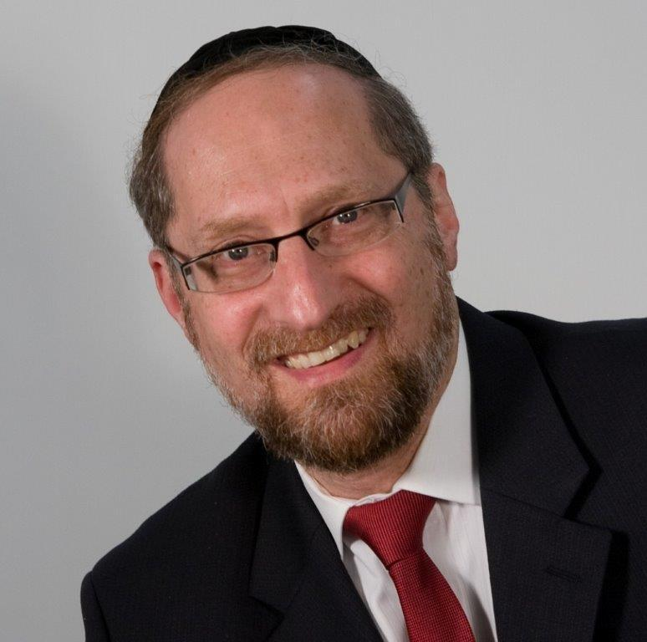

“If you go in my ways and follow my statutes…Five of you will chase a hundred, and a hundred of you will chase ten thousand, and they will fall from your sword.” Vayikra 26:8

The Torah is very explicit that if the Jewish nation follows the ways of HASHEM, we will enjoy peace, prosperity, and success in all of our endeavors. We will plant and harvest abundant crops, our borders will be secure, - life will be good. Included in this is a guarantee that in battle with our enemies we will be astonishingly successful; small numbers of our weakest soldiers will chase down and annihilate far larger groups of the enemy.

When describing this phenomenon, the Torah is very specific: five of you will chase a hundred, and a hundred of you will chase ten thousand. Rashi is troubled by the proportions. If five will chase a hundred, then the ratio is 1:20. By that proportion, a hundred should chase 2,000. Yet the Torah tells us that 100 will chase 10,000, a ratio that is five times greater than what it should be. Why would the group of a hundred be five times more effective than the group of five?

Rashi explains: “There is no comparison between a few keeping the Torah to a multitude keeping the Torah.”

Why should larger numbers make a difference?

It is clear from this Rashi that the only distinction between the two groups is in numbers. Rashi isn’t saying that the group of a hundred had more kavanah when they did the mitzvah. Nor is he telling us that they were greater people, or that they were engaged in a holier act. The only difference is that there are more of them involved. The question is: why should a larger group be exponentially more effective simply because of its size?

If Rashi were telling us that from a psychological standpoint there is strength in numbers and the group gives chizuk to each other so that they will fight better — it would make sense. Or if because they were a large assembly of people, they were strengthening each other in the purity of their intentions and were more l’shmo, we could understand why they would be more successful. However, that isn’t the difference. It is simply the fact that there are more of them. Why should the **same** people, on the **same** madgregah, doing the **same** mitzvah, be so many more times successful simply because they are a larger group?

The answer to this question lies in understanding the systems that HASHEM created and gave over to man.

**A change in the world order**

On August 6, 1945, the Japanese city of Hiroshima was obliterated. Never before in the course of history had man unleashed so much power and destruction in one act. For many, it took a long time to comprehend. How was it possible to destroy an entire city?

Man had been using explosives for thousands of years, but nothing of this magnitude. There were five hundred pound bombs that could destroy buildings, one thousand pound bombs that could level an apartment complex, but how did they wipe out a city? Miles and miles of rubble and destruction — everything leveled. “How large can the bomb possibly be? How many explosives can you possibly pack into one plane?”

The reason that it was so difficult to comprehend was because the force was derived from a completely different set of principles and didn’t work with the old rules. HASHEM had allowed man to harness the power of the atom — an energy source more than a million times more powerful than conventional weapons. It was a whole new reality, and the old frame of reference had little bearing.

So too, in the spiritual world, HASHEM has created certain forces that are powerful and magnify the efforts of man a thousand fold or more. When a sofer takes parchment and ink, writes the parshios with the right intentions, and inserts them into properly prepared batim, an object has been created. That object is far greater than any of its parts.

A pair of tefillin is one of the holiest objects in creation. The parshios themselves had a certain level of kedsuha; the batim themselves prepared l’shmo have some holiness to them. But when all of the parts are brought together, it creates a new entity that is exponentially more holy and potent than the sum of its parts. A kosher pair of tefillin has been created. The object itself is now kodesh, and when man wears them, he harnesses powerful forces that affect both this world and the upper worlds in ways that are difficult to imagine.

So too, when Jews gather together to perform a holy act, it is no longer ten or twenty individuals; it is a new entity – a tzibbur. That tzibbur is far more powerful than the sum of all of its members. It is now in a new category and taps an energy source that is infinitely more powerful than any of the individual members can muster. The impact and effect that it brings about is far greater and it can now accomplish far more than any of its members acting alone.

**The power of a tzibbur**

This seems to be the answer to this Rashi. Much like a kosher pair of tefillin or a complete sefer Torah, a hundred Jews acting in unison reach a new plateau of effectiveness, multiple times that of the individuals involved. They have tapped the force of the tzibbur. A hundred will chase ten thousand.

This concept has great relevance to us in helping us be more successful. The Gemarah (Tannis 8a) tells us that while all prayer works, for it to be **heard**, it must be said with an outpouring of emotion. Only when tefillah comes from a deep devotion and is expressed with sincere, powerful intention will it move mountains… unless it is said b’tzibbur. Then, with or without this deep level of Kavanah, it will accomplish its intended purpose.

It is clear from the Gemarah that the same **prayer**, the same **intention**, and the same **person** will find much greater results from his davening because has joined a minyan. He may not have changed, but his circumstances have. He is now in a assemblage that has joined together, and its efficacy far outweighs that of all the individuals combined. By sharing in the merit of that group, his prayer will have a far greater effect. He has put the power of a tzibbur to work.

*Reprinted from this week’s website on TheShmuz.com This is an excerpt from the*[*Shmuz on the Parsha book*](https://theshmuz.com/product/shmuz-on-the-parsha-book/)*.*

**Coronavirus and the**

**Jewish Community**

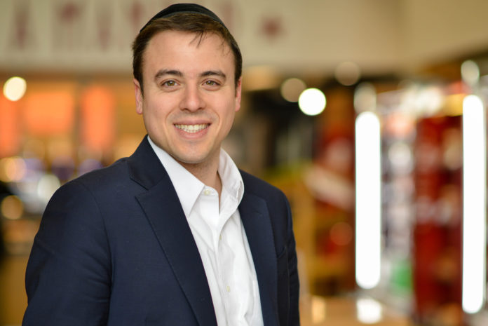

**Dr. Steven Tzvi Pirutinsky of Touro’s Graduate School of Social Work Assesses Impact, Coping Strategies**

Coronavirus has upended lives all over the globe. For the Jewish community where so much of daily life revolves around religious and social gatherings, the outbreak has been particularly devastating. From daily minyan to life cycle events such as weddings, bar mitzvahs, brises and funerals, Jews are a people who congregate.

To assess the social and psychological impact of the coronavirus pandemic on the Jewish community, Dr. Steven Tzvi Pirutinsky, associate professor at Touro College Graduate School of Social Work, is conducting a research study. The views, feelings and thoughts of Jews from all over the globe, representing every denomination will be represented in this research.

The study was designed with the assistance of Drs. David Rosmarin (Harvard), David Pelcovitz (Yeshiva University), Aaron Cherniak (Stockholm University), Moshe Krakowski (Yeshiva University), and Yitzchak Schechter (Applied Research and Community Collaboration Institute).

“We wanted to look at what factors affect mental health during this outbreak, assess what coping strategies work for different people and make recommendations that can help people moving forward as future challenges arise,” said Pirutinsky.

In terms of the factors affecting mental health, the researchers will look at exposure to Coronavirus directly and through media, mental health, and what role Judaism plays in helping people cope with these situations. They will also look at compliance with medical and government recommendations as well as recommendations from religious leaders and the trust people place in each of these authorities.

“A key factor we will assess is the role of the media in contributing to stress. We will look at both news and social media –how often people are checking their social feeds, tuning in to news broadcasts and reading news articles and how this barrage of information is helping or hurting them,” said Pirutinsky.

Researchers will look at age differences in coping mechanisms and generational challenges and the relationship between ages and life stages and ability to cope. These patterns will likely differ, according to Pirutinsky, from a young person with less responsibilities to parents with young children at home and elderly, isolated people who are at higher risk from the virus. They will also look at which subgroups are hardest hit –those from particular geographic areas, the differences family size makes and those who identify with particular segments of the Jewish community.

**Coping Strategies – the Good and the Bad**

In terms of coping strategies, they will look at both positive and negative methods including social activity, exercise, religious strategies, various forms of entertainment, as well as substance use.

“We will look at what role Judaism plays in helping people cope. What happens when religious rituals and activities such as going to shul, attending weddings and getting together with family on Shabbat and holidays are unavailable? What is the role of faith in coping with a crisis? In this context, we will also look at the passive or active approaches people take in terms of medical attention. The question of the degree to which people feel G-d cares about them in this crisis and whether He is sending a message to the Jewish people will be addressed as well,” said Pirutinsky.

More than 500 people from around the world are participating in this study and it is still open for additional participants.

“We really want to see how people are coping with this crisis –what’s more effective and what’s less helpful. We want to understand how Jewish people react to crisis, what role religion, culture and social circumstance play in the degree to which people are impacted and how they cope. We assume there won’t be another coronavirus, but there will certainly be other major challenges for our community and we believe we can make future recommendations for what works based on this experience,” said Pirutinsky.

Those interested in participating can take the 20 minute survey here <https://tourocollege.az1.qualtrics.com/jfe/form/SV_5C3Y2y7Ny7yuUYJ>

*Reprinted from the April 29, 2020 website of Matzav.com*